Ideation Phase Empathize & Discover

Date | 15 Feb 2026
Team ID | LTVIP2026TMIDS45159
Project Name | Measuring the Pulse of Prosperity: An Index of Economic Freedom Analysis
Maximum Marks | 4 Marks

Empathy Map Canvas:
An empathy map is a simple visual tool used to understand users’ needs, challenges, and decision-making behavior.
The primary users of the Economic Freedom Analysis Dashboard are policymakers, economists, research scholars, and data analysts who need to monitor national economic performance and understand the impact of unemployment and other economic indicators on prosperity.
These users often work with large and complex datasets containing economic indicators such as unemployment rate, inflation, GDP growth, and economic freedom scores. Without a centralized visual analytics platform, it becomes difficult to identify patterns, compare countries, and evaluate economic health.
Due to the absence of interactive and visual analytics tools, users may feel overwhelmed and uncertain while making policy decisions or economic assessments. They require a user-friendly Tableau dashboard with clear KPIs, comparative country rankings, trend analysis, and filtering options to transform complex data into meaningful insights.
Such a dashboard enables data-driven decision-making and supports strategic planning for improving national economic performance and prosperity.

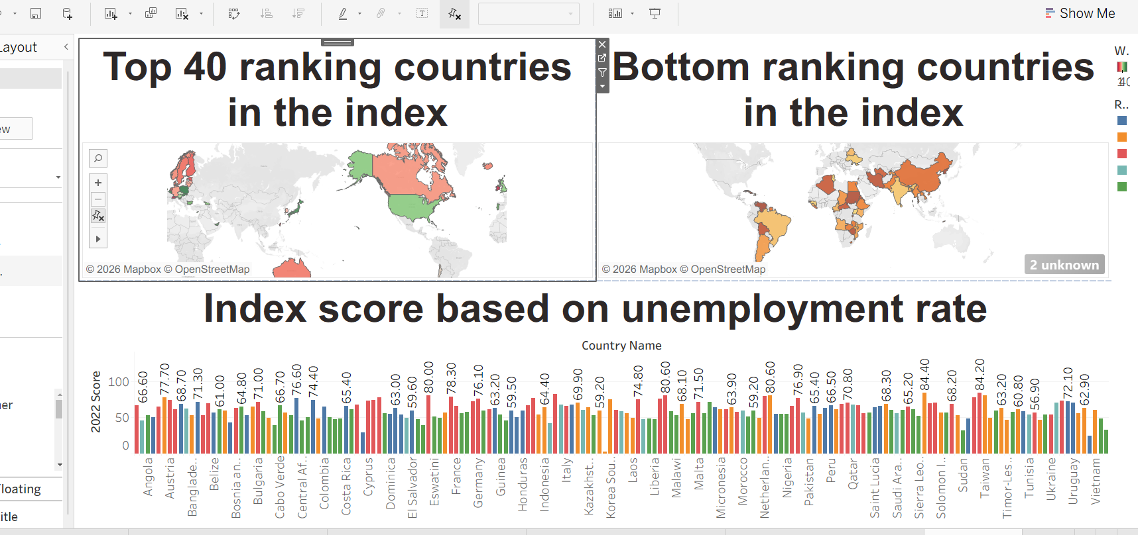
Data -driven decision making for future planning

